**Togo country profile**

Published

24 February

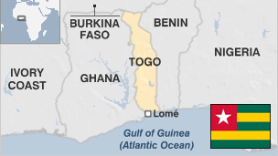

**Togo, a narrow strip of land on Africa's west coast, has for years been the target of criticism over its human rights record and political governance.**

Granted independence from France in 1960, Togo has struggled to build a stable country and economy.

The country has gained notoriety as a transit point for ivory poached elsewhere in the region. Poaching has risen in recent years across the continent, where well-armed criminal gangs kill elephants for tusks and rhino for their horns, before shipping them to Asia for use in ornaments and supposed medicine.

Togo is one of the world's top five producers of phosphates, which are used in fertilisers, but remains poor and dependent on foreign aid.

* Read more profiles by [BBC Monitoring](http://bbc.co.uk/monitoring)

**President: Faure Gnassingbe Eyadema**

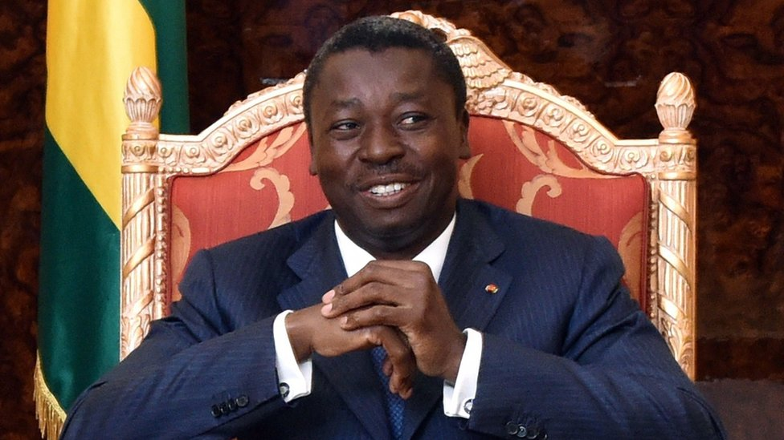image copyrightGetty Images

Faure Gnassingbe Eyadema succeeded his father, who died in 2005 after ruling the country with an iron fist for 38 years.

The military installed Faure Gnassingbe as president, but following intense domestic and international pressure he called elections. Hundreds died challenging his victory in those polls.

Gnassingbe has won three more elections, in 2010, 2015 and 2020. All were criticised by the opposition.

Constitutional changes in 2019 allowed President Gnassingbe to seek re-election and potentially stay in office until 2030 - an issue that sparked huge protests in 2017-18.

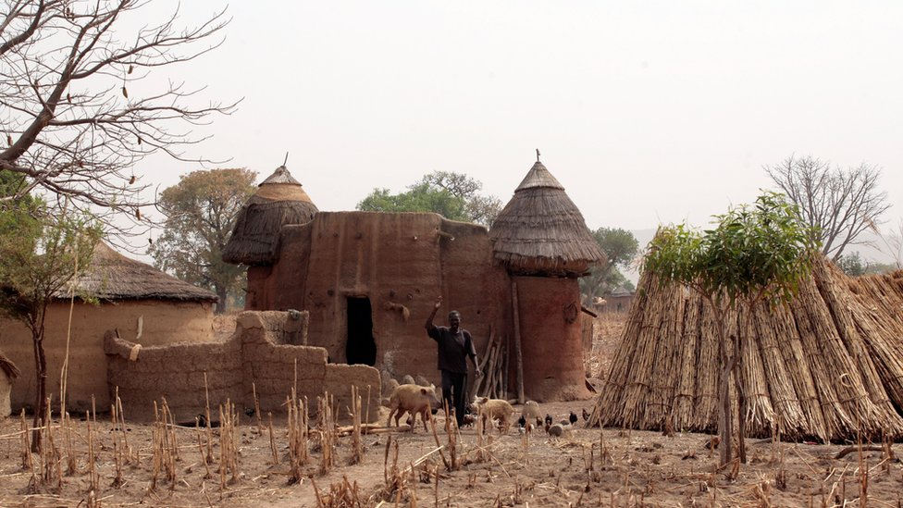image copyrightGetty Images

image captionKoutammakou, the Land of the Batammariba in north-eastern Togo, is listed as a World Heritage Site

Radio is the most popular medium, particularly in rural areas. The main TV station is government-owned Television Togolaise. The government also operates Togo-Presse daily.

Private media have proliferated. There are dozens of commercial and community radios and weekly newspapers, as well as a handful of private TV stations.

A penal code criminalising media offences was introduced in 2015, raising media freedom concerns.

# Togo profile - Timeline

Published

10 May 2018

**A chronology of key events:**

**15-17th centuries** - Ewe clans from Nigeria and the Ane from Ghana and Ivory Coast settle in region already occupied by Kwa and Voltaic peoples.

**1700s** - Coastal area occupied by Danes.

**1884** - German protectorate of Togoland established, forced labour used to develop plantations.

**1914** - British, French forces seize Togoland.

**1922** - League of Nations issues mandates to Britain to administer the western part and to France to rule the eastern area of Togoland.

## Independence

**1956** - British-ruled western territory included into the Gold Coast, later renamed Ghana.

**1960** - Independence.

**1961** - Sylvanus Olympio elected as first president.

**1963** - Olympio assassinated, replaced by Nicolas Grunitzky.

**1967** - Gnassingbe Eyadema seizes power in bloodless coup, political parties dissolved.

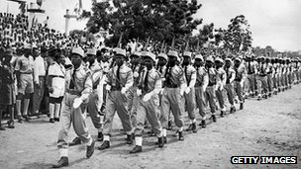image copyrightGetty Images

image captionTogo gained independence in 1960

**1974** - Phosphate industry nationalised.

**1979** - Eyadema, standing as sole candidate, elected as president in first parliamentary polls since 1967, under constitution entrenching civilian, one-party rule.

**1985** - Series of bombings in Lome.

**1985** - Coup attempt, French troops come to government's assistance. Togo accuses Ghana and Burkina Faso of involvement. Togo's frontier with Ghana shut until 1987.

**1986** - Exiled opposition leader Gilchrist Olympio sentenced to death in absentia for complicity in 1985 coup attempt.

**1986** - Eyadema re-elected.

**1991** - Strikes, demonstrations. Eyadema agrees to split power with transitional adminstration pending elections.

**1992** - New constitution approved.

**1993** - Eyadema dissolves government, sparking protests and fatal clashes with police. Thousands flee to neighbouring states.

**1993** - France, Germany, US suspend aid to press for democratic reforms.

**1998** - Eyadema re-elected.

**2000** March - UN report alleges that presidents Blaise Compaore of Burkina Faso and Gnassingbe Eyadema of Togo helped the Angolan rebel group Unita get arms and fuel in exchange for diamonds. Both countries deny the accusations.

**2001** February - UN-OAUl inquiry into allegations of summary executions and torture in Togo concludes there were systematic violations of human rights after 1998 presidential election.

**2001** August - Opposition leader Yawovi Agboyibo is jailed for six months for libelling the prime minister. Demonstrators take to the streets.

**2002** June - Eyadema sacks his prime minister and ally Agbeyome Kodjo and says the action is in preparation for parliamentary elections. Kodjo lambasts the president and accuses his aides of corruption and human rights abuses.

**2002** October - Ruling party wins parliamentary elections. Main opposition parties stage boycott in protest at way poll was organised.

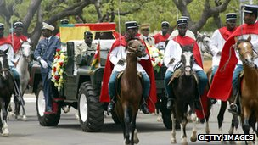image copyrightGetty Images

image captionThe funeral of President Eyadema

**2002** December - Parliament alters the constitution, removing a clause which would have barred President Eyadema from seeking a third term in 2003.

**2003** June - Eyadema re-elected. Prime Minister Koffi Sama and his government resign.

**2003** July - President Eyadema reinstates Koffi Sama as prime minister. A unity government is announced but the main opposition parties are not included.

**2003** September - Togo sends 150 soldiers to Liberia to bolster a West African peacekeeping force.

**2004** November - European Union restores partial diplomatic relations. Ties were broken in 1993 over violence and democratic shortcomings.

**2005** February - President Gnassingbe Eyadema dies, aged 69. The military appoints his son Faure as president in a move condemned as a coup. Under international pressure Faure stands down and agrees to hold presidential elections.

## Faure Gnassingbe elected

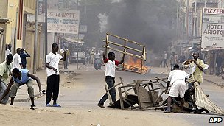image copyrightAFP

image captionElections in 2005 were followed by deadly violence

**2005** April - Faure Gnassingbe wins presidential elections which the opposition condemns as rigged. The vote is followed by deadly street violence between rival supporters. The UN later estimates that 400-500 people were killed.

**2005** June - President Gnassingbe names opposition's Edem Kodjo as prime minister.

**2006** April - Reconciliation talks between government and opposition resume. Dialogue was abandoned after Gnassingbe Eyadema's death in 2005.

**2006** August - Government and opposition sign an accord providing for the participation of opposition parties in a transitional government.

**2006** September - Yawovi Agboyibo, veteran leader of the opposition Committee of Action for Renewal, is named prime minister and tasked with forming a unity government and organising polls.

**2007** February - Exiled opposition leader Gilchrist Olympio returns home briefly.

**2007** October - Ruling Rally of the Togolese People party wins parliamentary election. International observers declare the poll free and fair.

**2007** November - The European Union restores full economic cooperation after a 14-year suspension, citing Togo's successful multi-party elections.

**2007** December - Rally of the Togolese People's Komlan Mally appointed prime minister

**2008** September - Former UN official Gilbert Houngbo appointed prime minister with support of governing Rally of the Togolese People.

**2009** April - President Gnassingbe's half-brother and former Defence Minister Kpatcha Gnassingbe and several army officers are arrested in connection with an alleged coup plot against the president.

**2009** June - Togo abolishes death penalty.

**2010** January - Togo quits African Cup of Nations football tournament in Angola after an attack on its team bus kills two officials.

## Gnassingbe re-elected

**2010** March - President Gnassingbe declared winner of presidential elections. The main opposition Union of Forces for Change alleges widespread fraud and refuses to recognise the result.

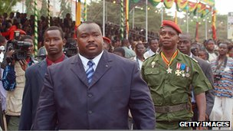image copyrightGetty Images

image captionKpatcha Gnassingbe was defence minister and convicted of plotting a coup

**2010** May - Veteran opposition leader Gilchrist Olympio agrees power-sharing deal with ruling party, splitting his Union of Forces for Change (UFC).

**2011** March - Police break up protests against planned legislation which would restrict street demonstrations.

**2011** September - President's half-brother Kpatcha Gnassingbe sentenced to jail for plotting to overthrow him.

International Maritime Bureau voices concern over increasing violence being practiced by pirates off the West African coast.

**2012** June - Clashes as demonstrators gather in Lome to protest against reforms to the electoral code that favour the ruling party.

**2013** July - Long-delayed elections. Ruling party wins two-thirds of parliamentary seats. Opposition party Let's Save Togo alleges irregularities.

**2015** May - Opposition candidate Jean-Pierre Fabre refuses to recognise President Gnassingbe's victory in elections.

**2019** May - Constitutional changes allow President Gnassingbe to seek re-election and potentially stay in office until 2030 - an issue that sparked huge protests in 2017-18.

**2020** February - President Gnassingbe re-elected, opposition leader Agbeyome Kodjo accuses authorities of widespread fraud.